**Task 1 (1 mark):**

− Upload the files in Pig and Hive as specified in our tutorials.

− Provide one screenshot (first page) per table.

AwardsCoaches Table:

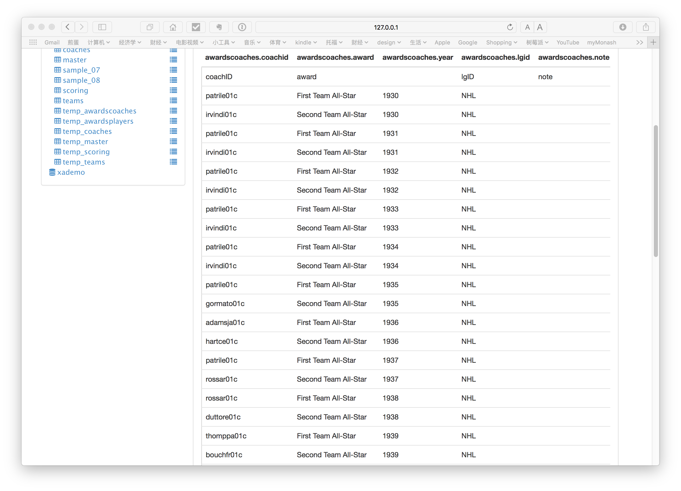

AwardsPlayers Table

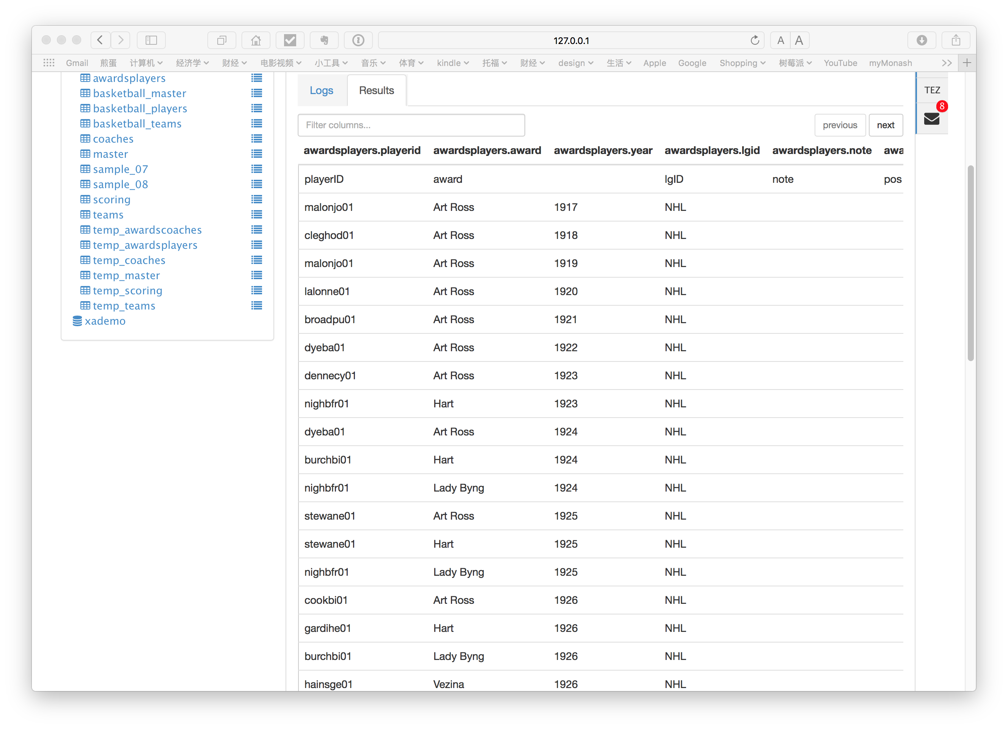

Coaches Table

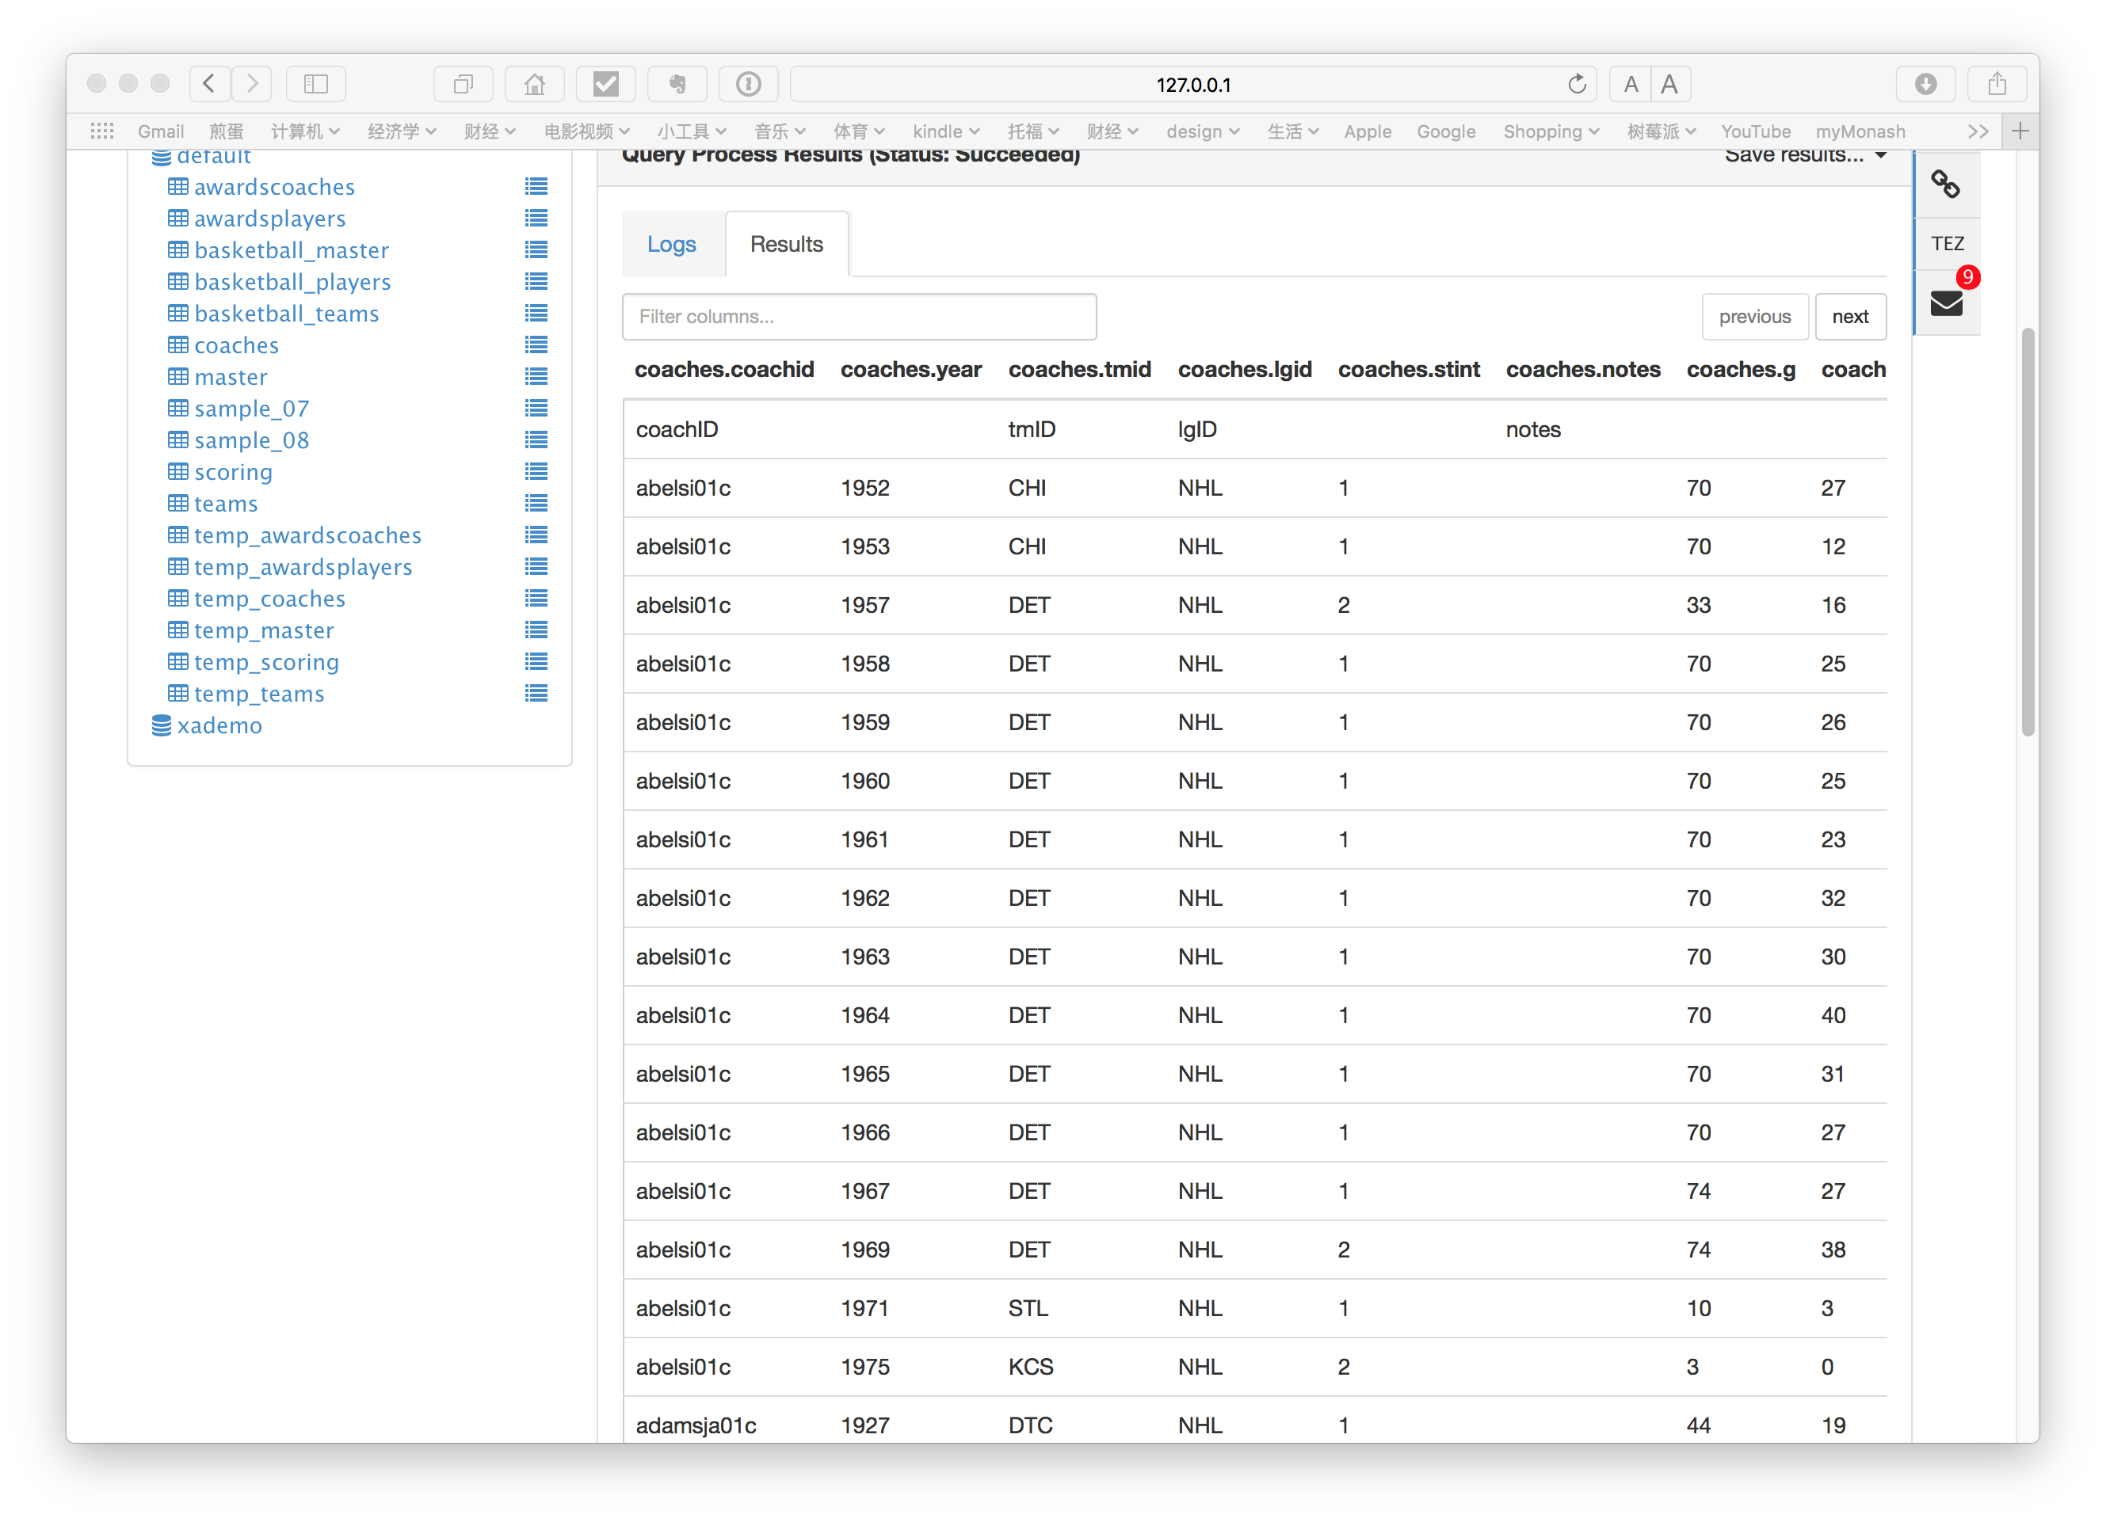

Master table

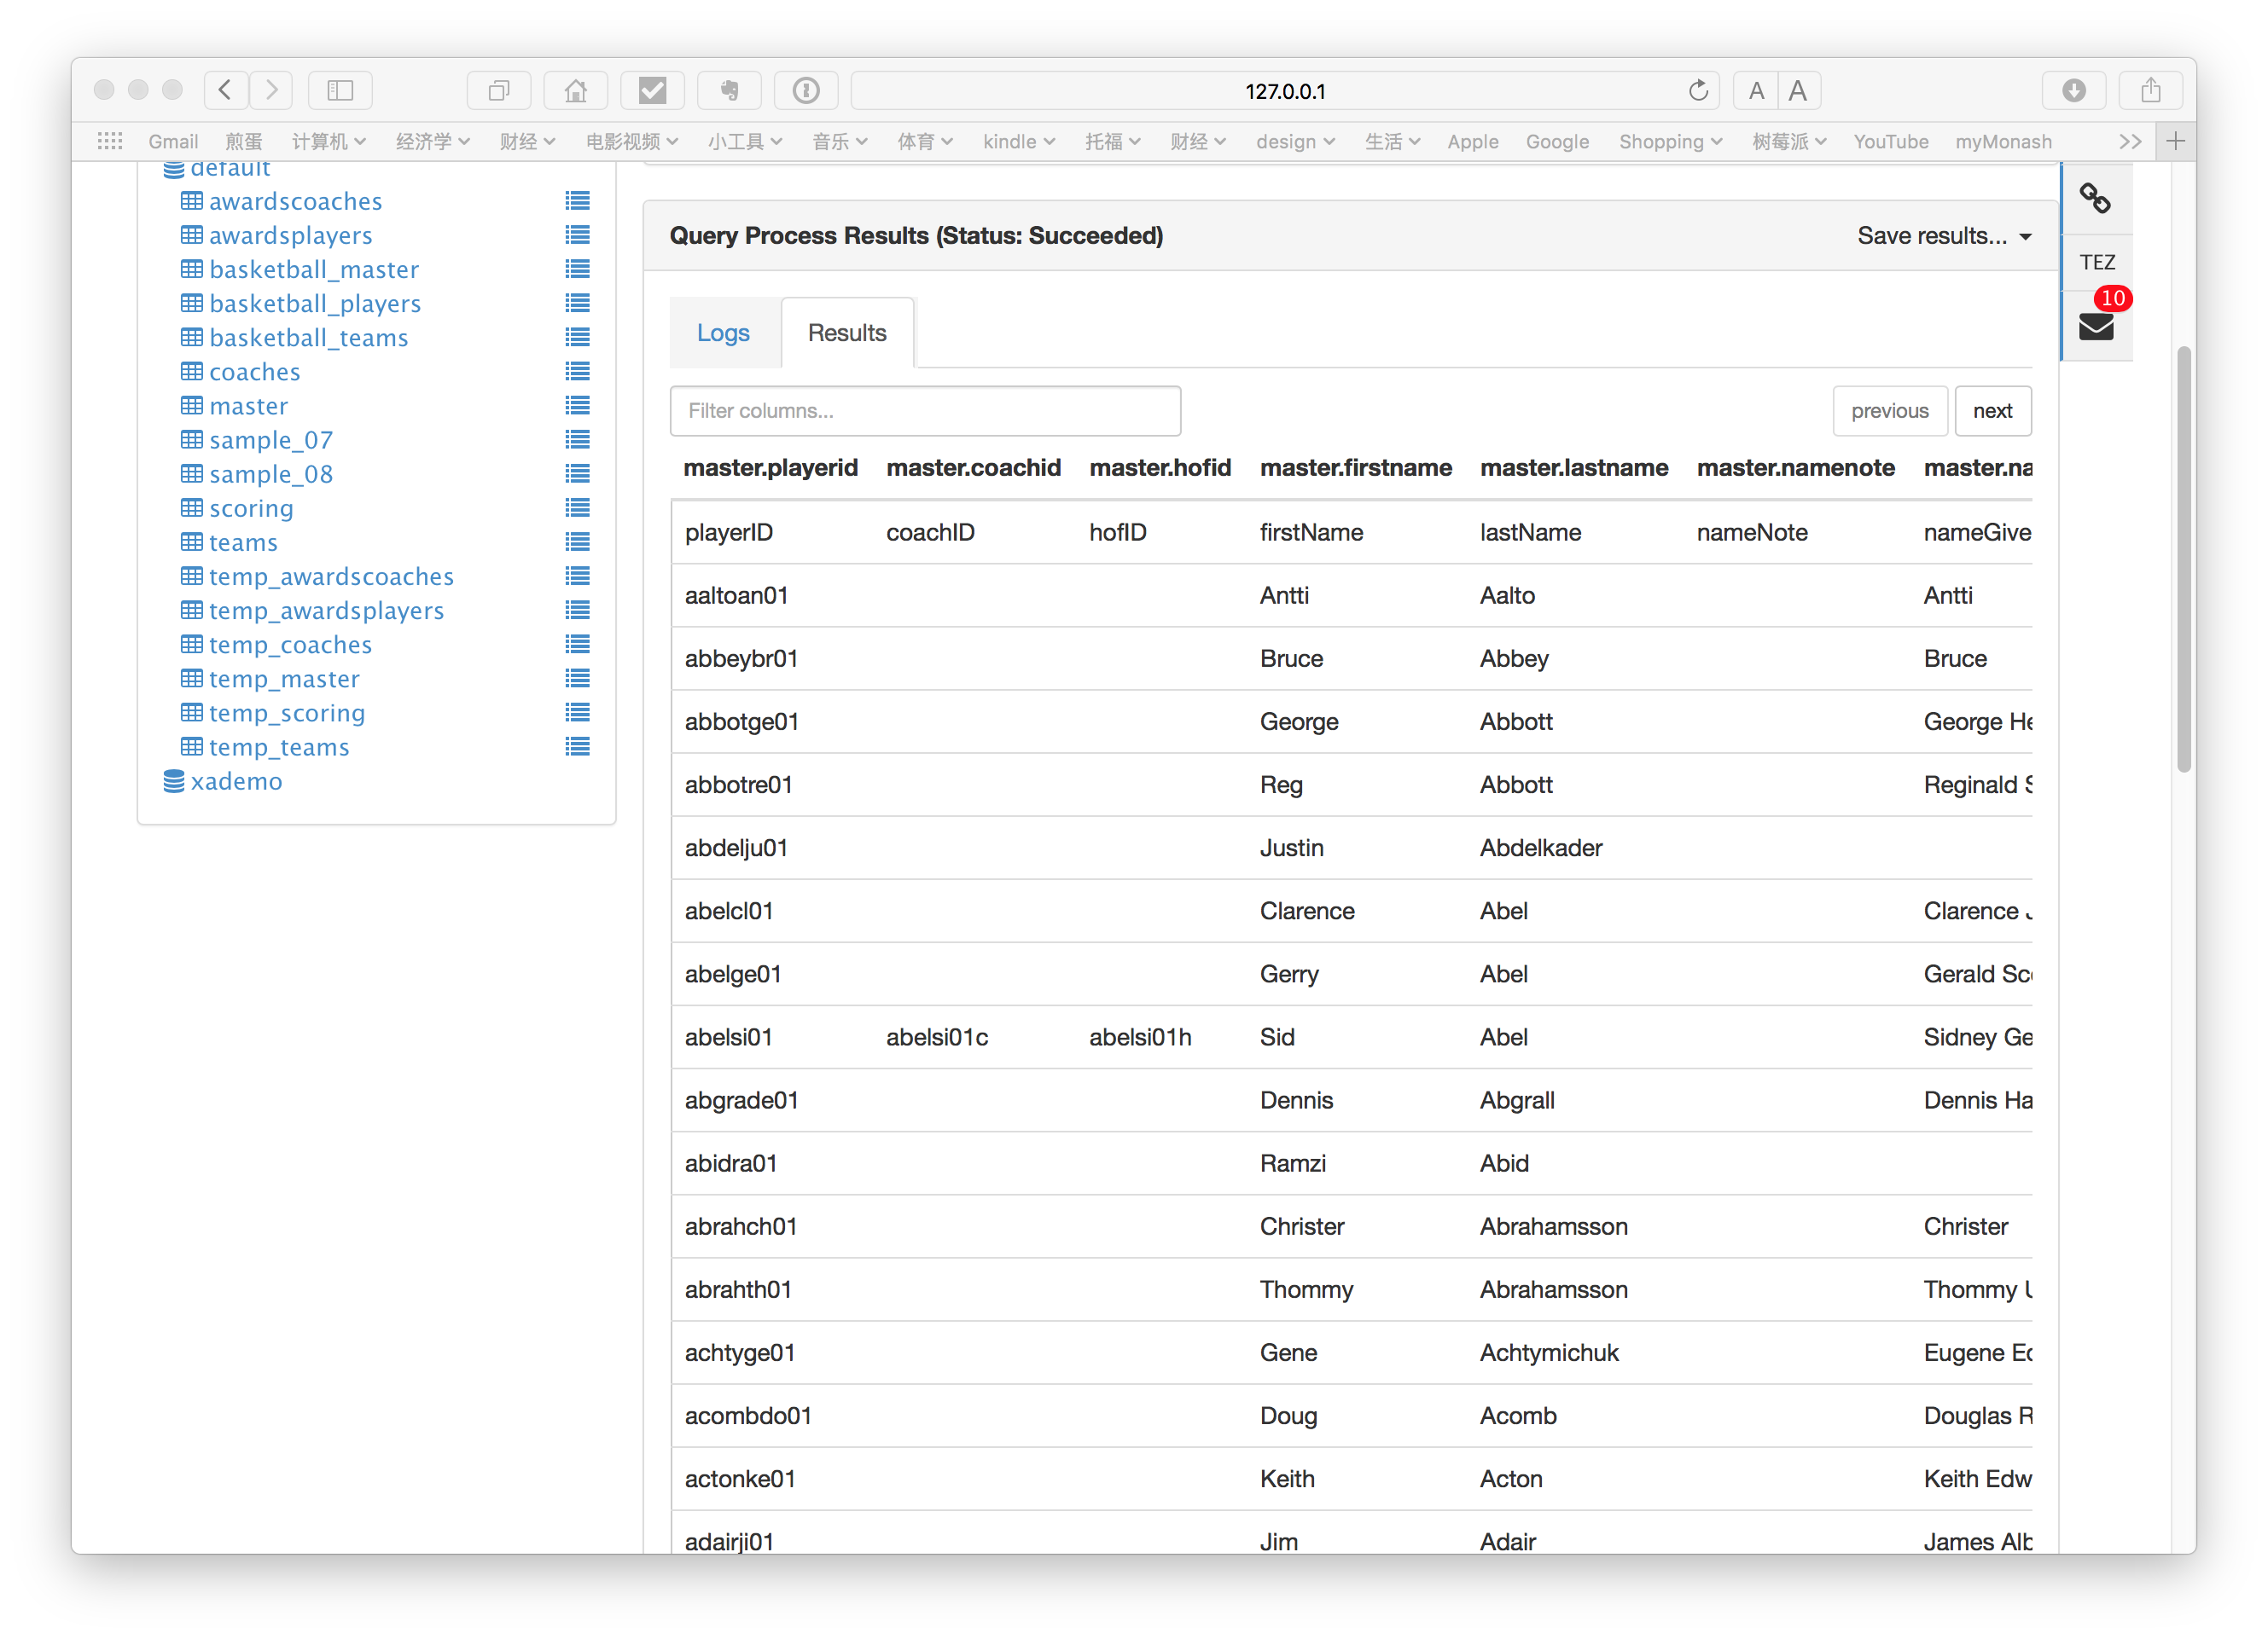

Scoring Table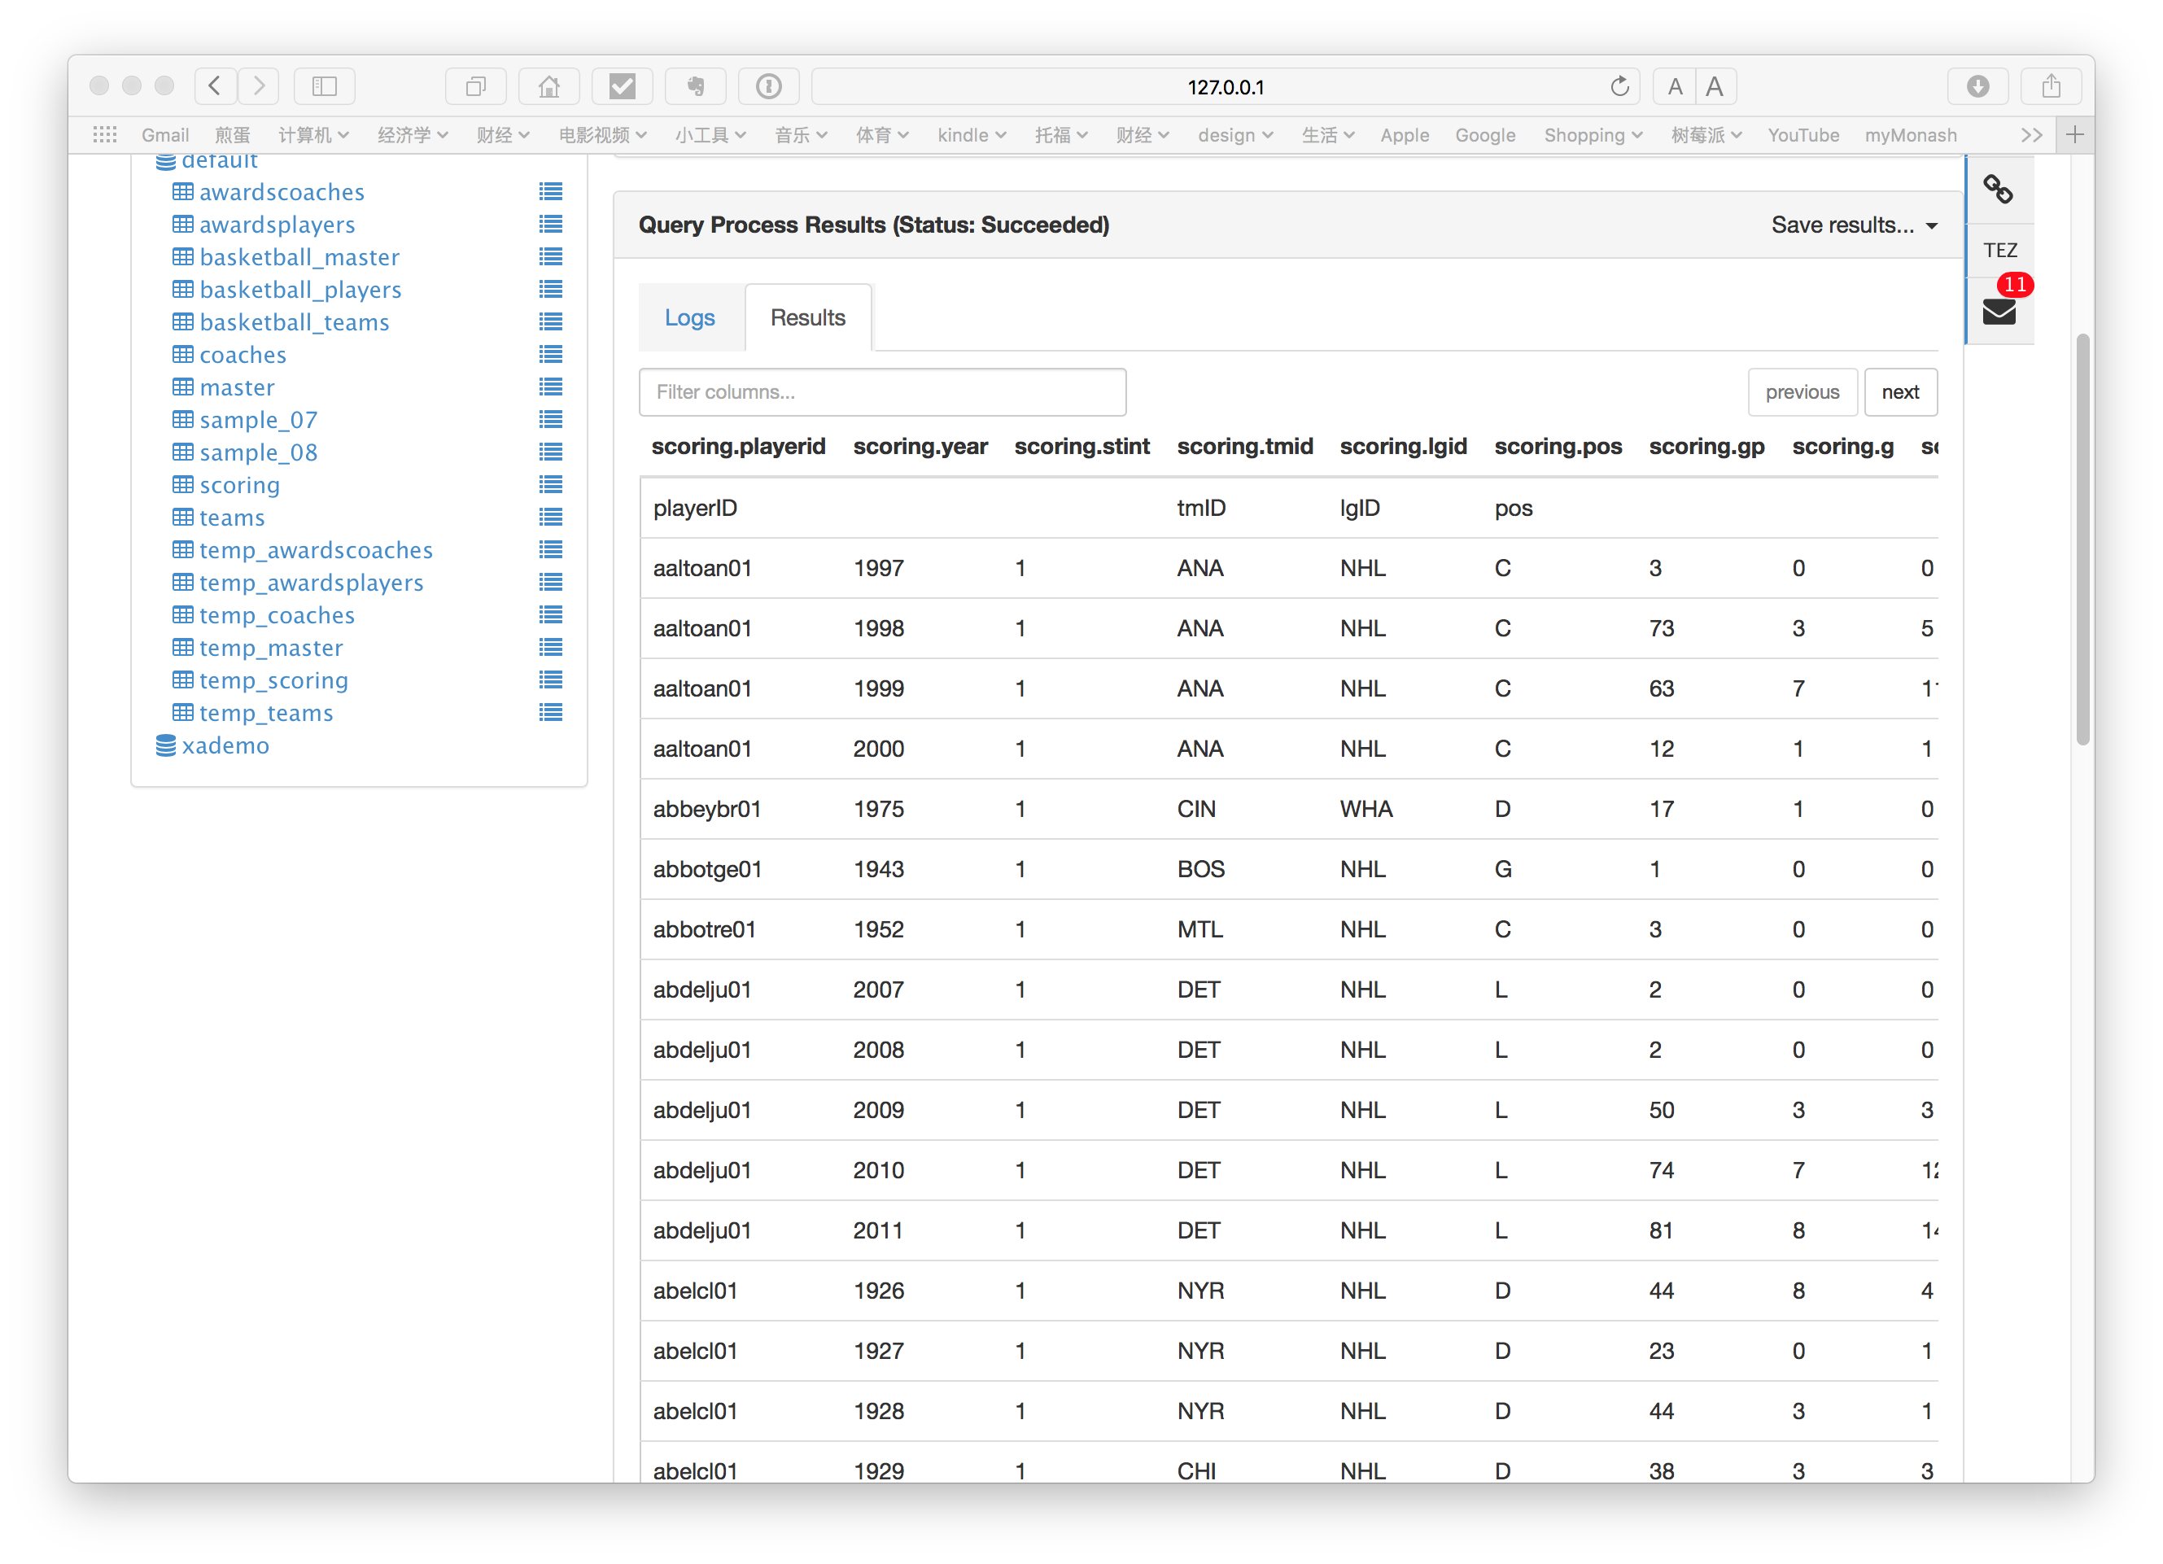

Teams

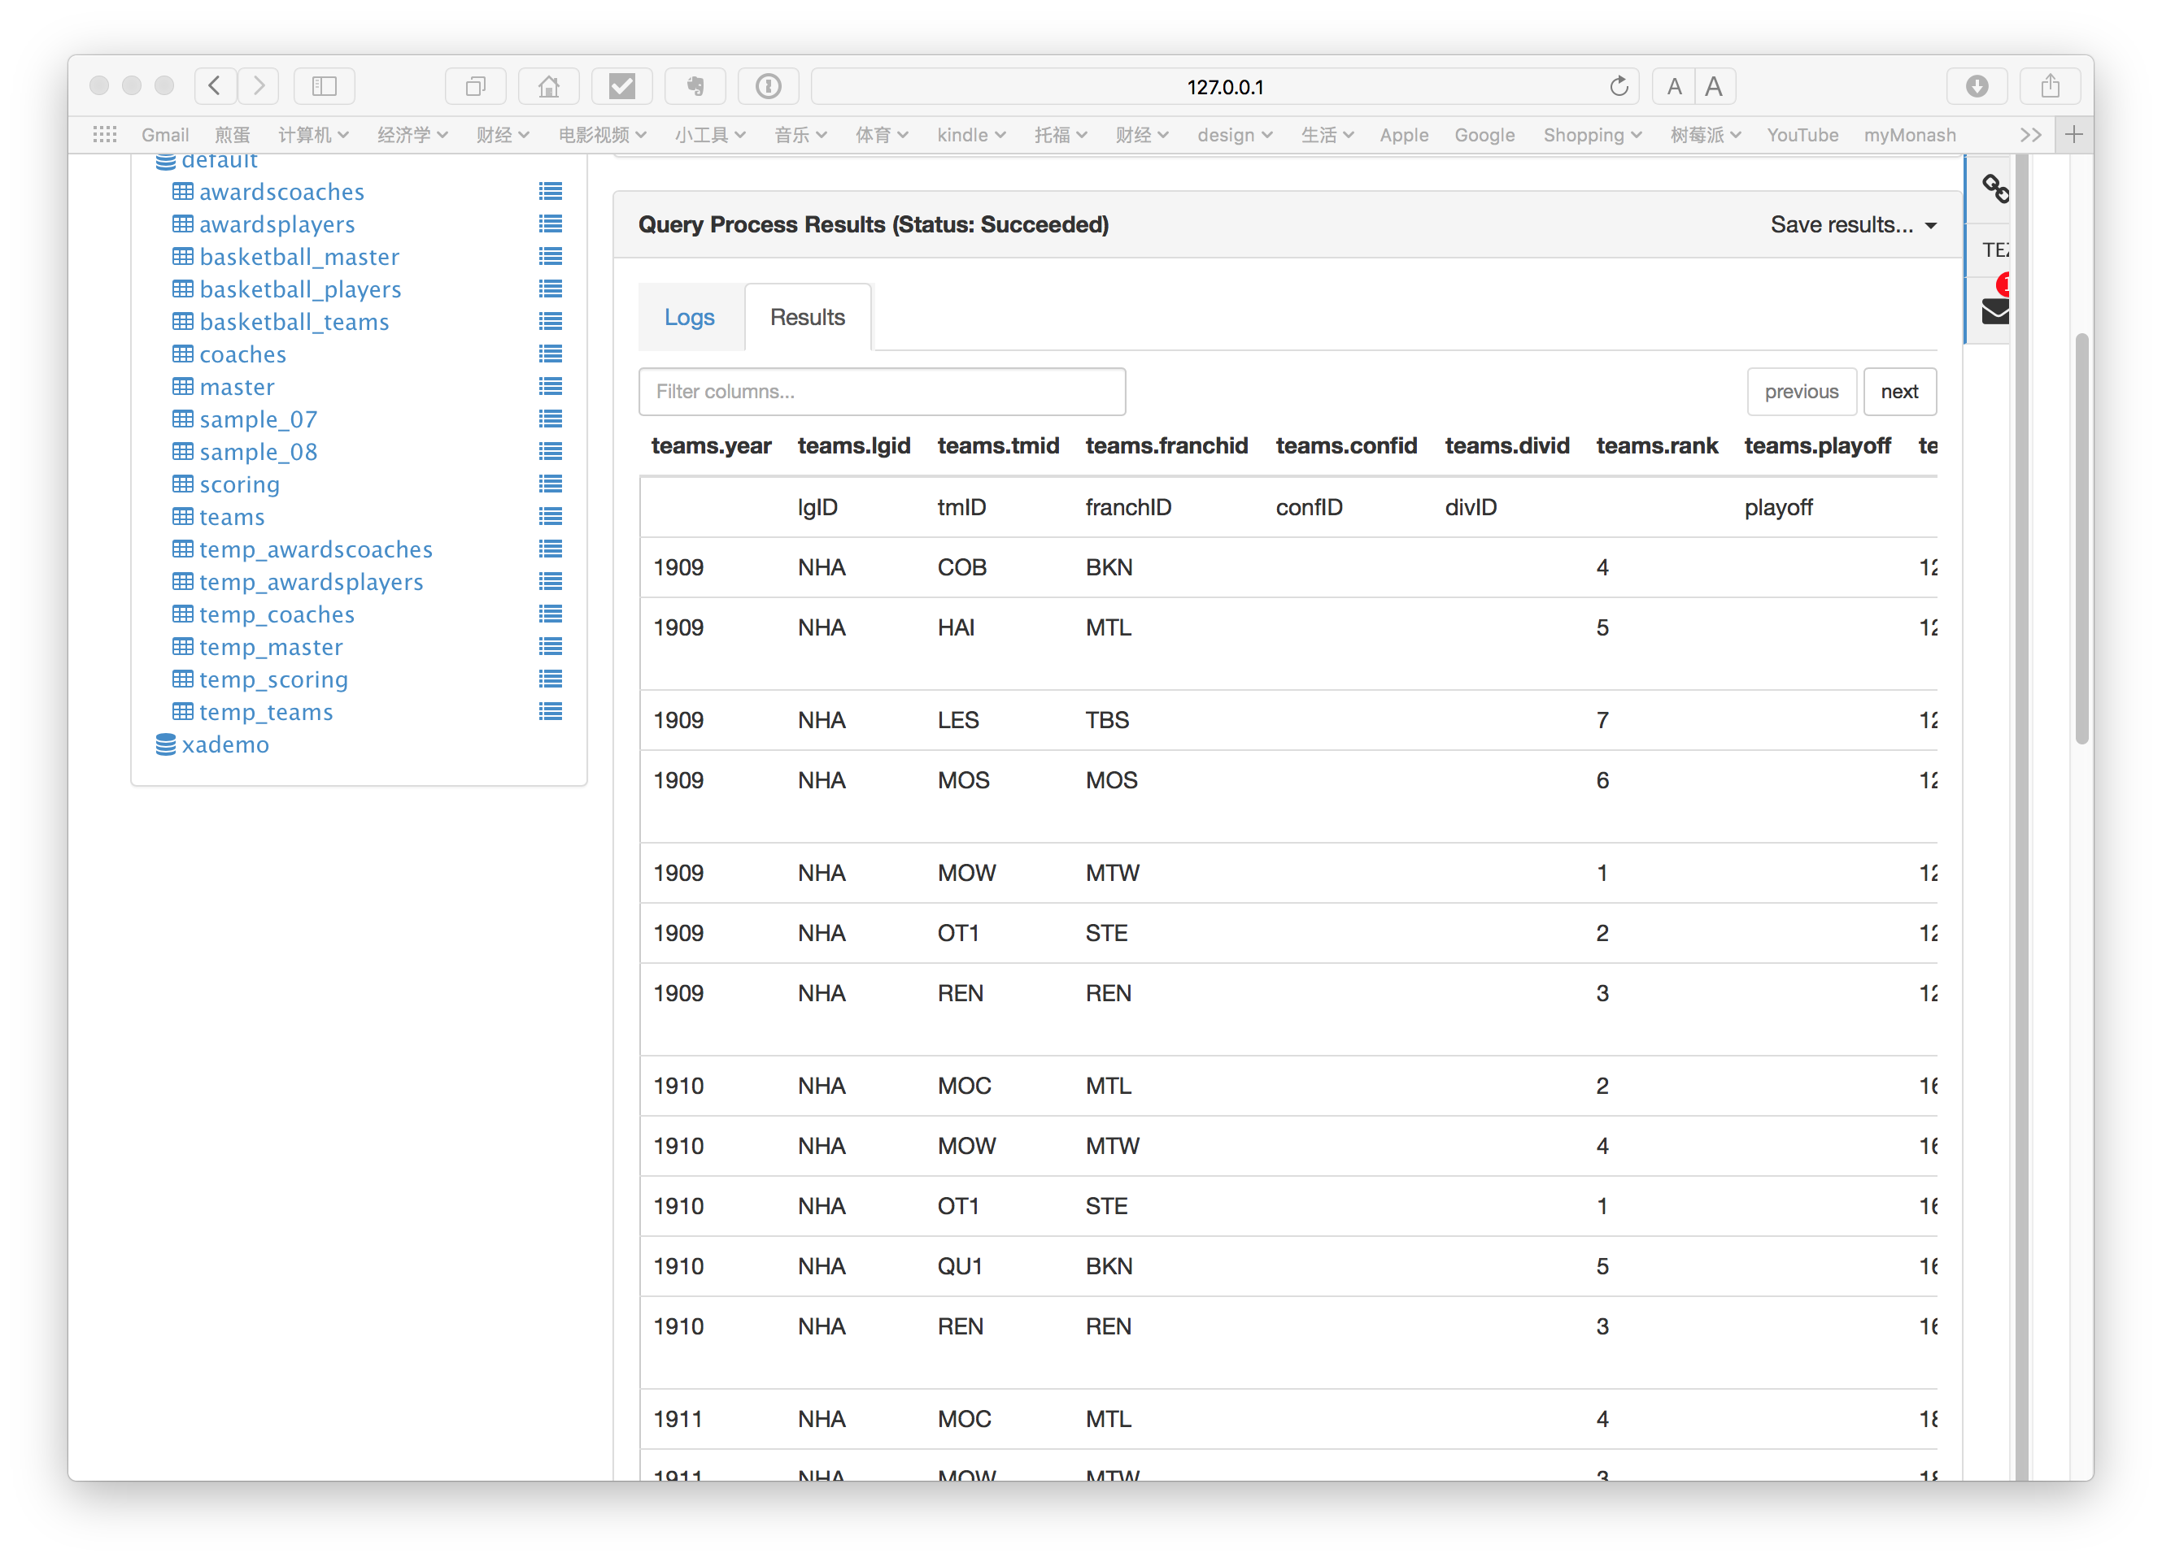

Pig:

AwardsCoaches table

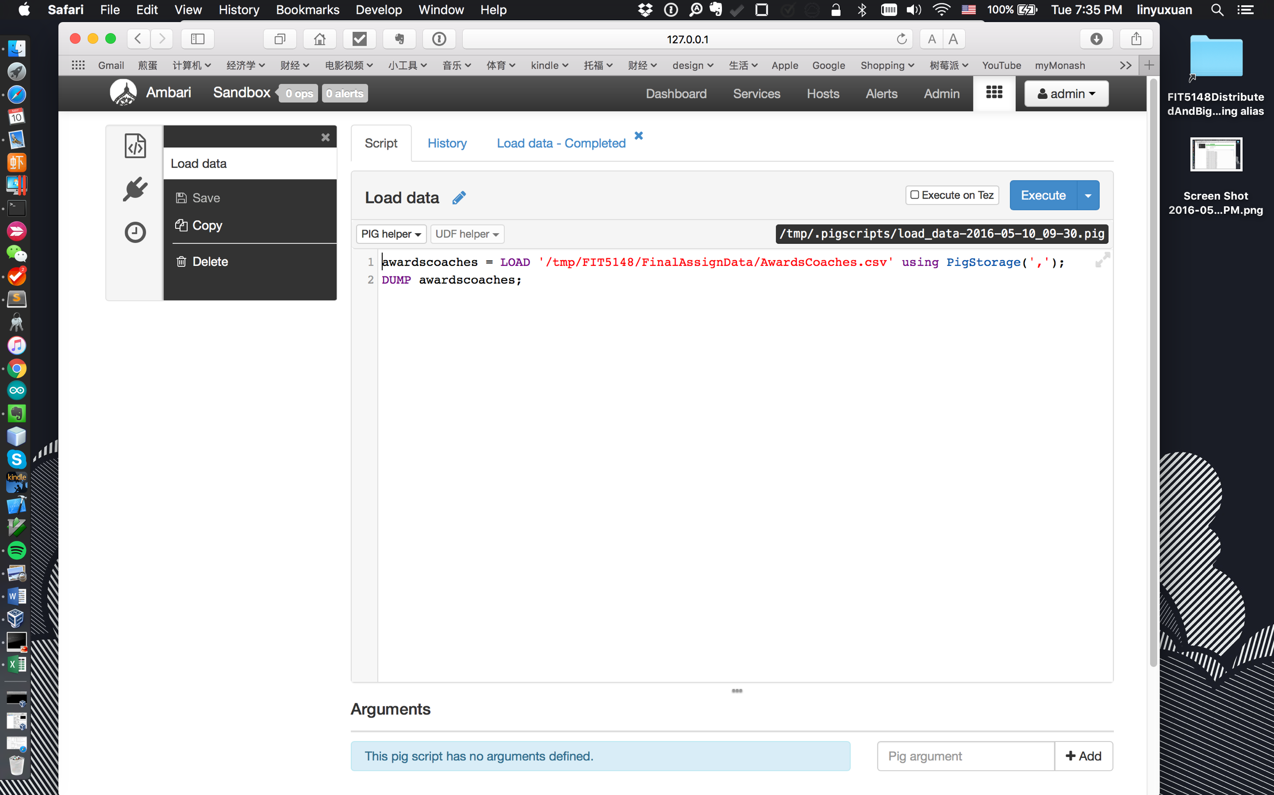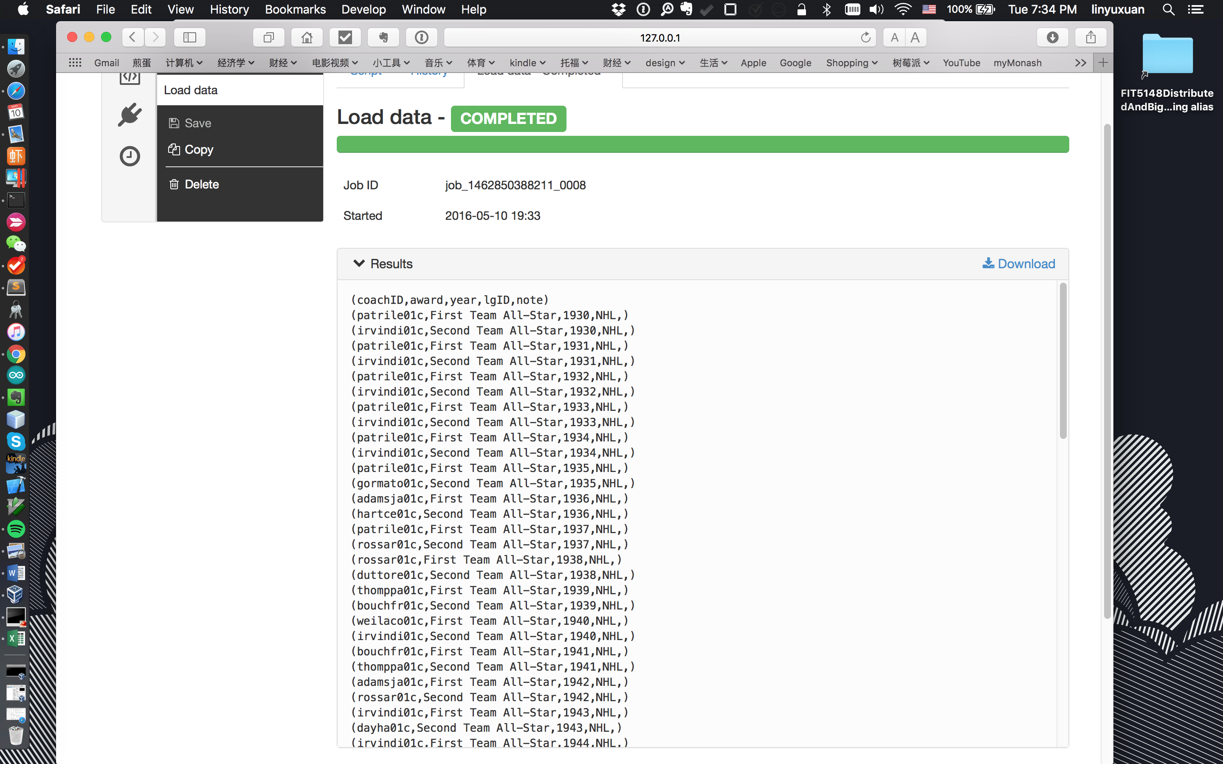

AwardsPlayers table

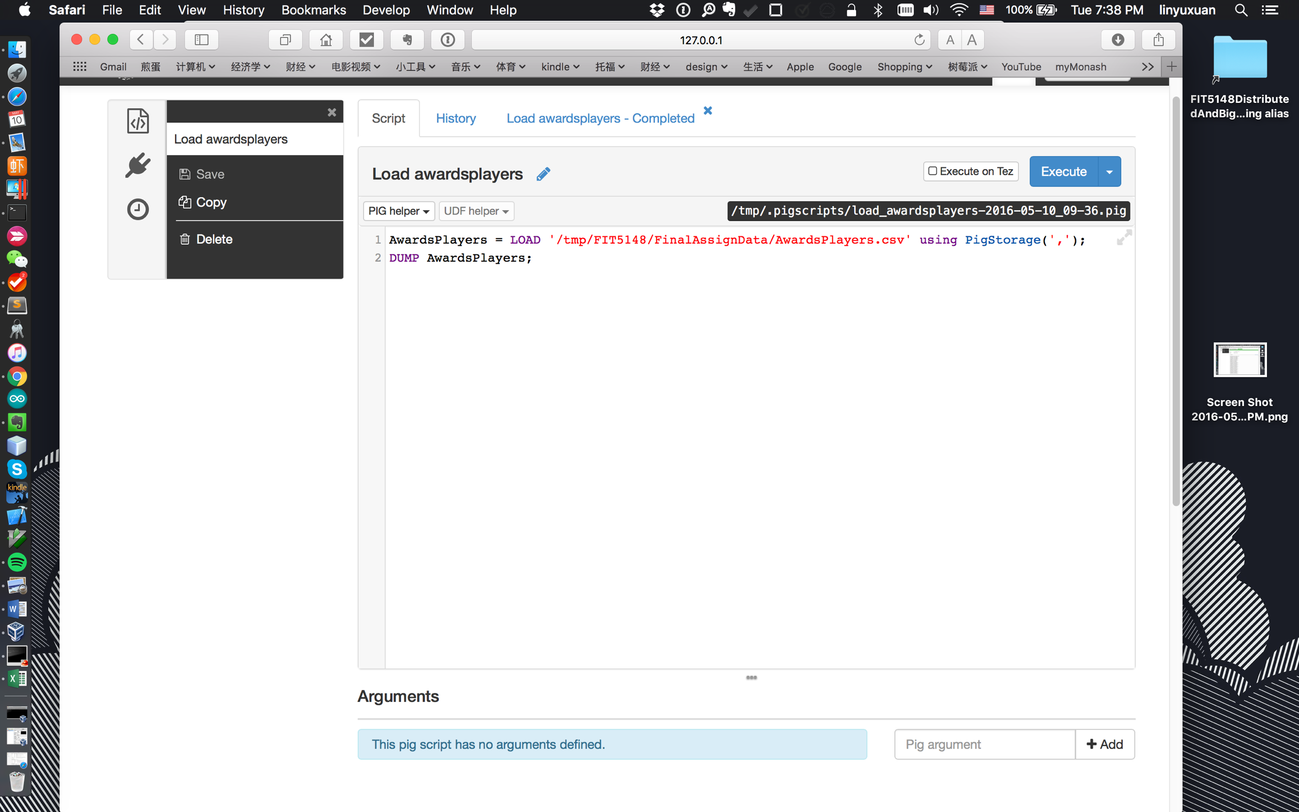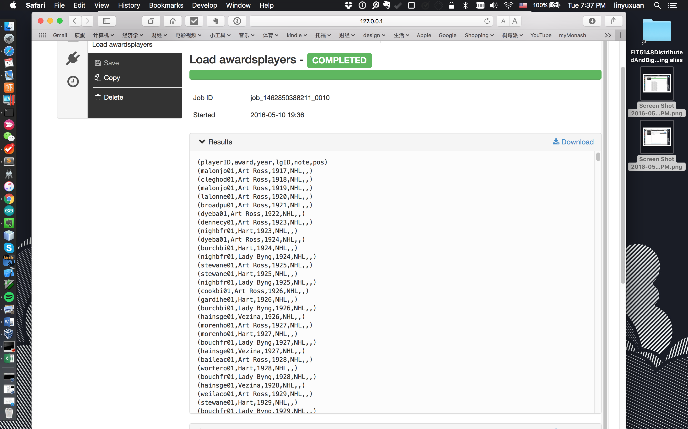

Coaches table

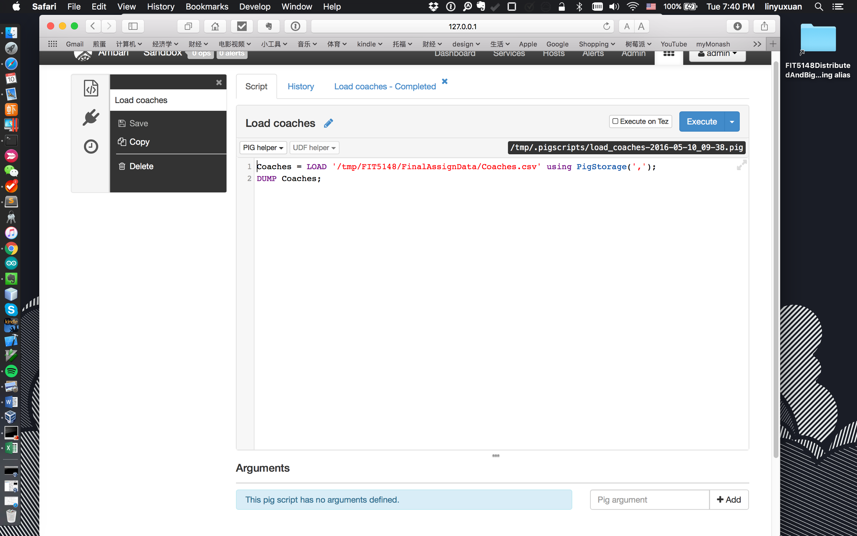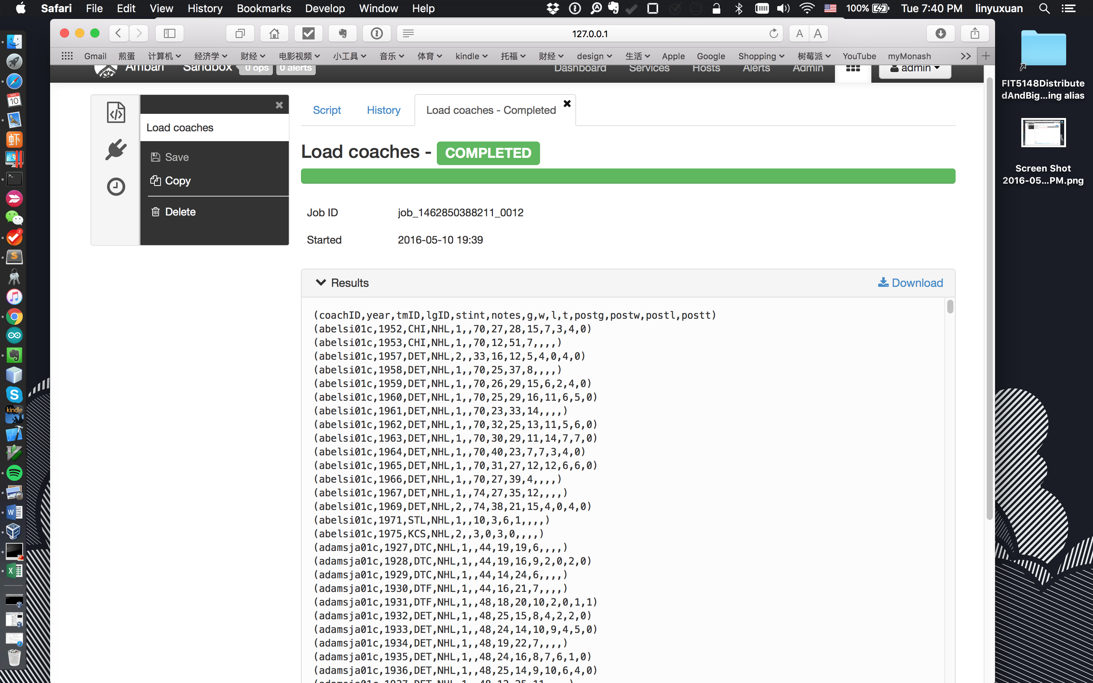

Master table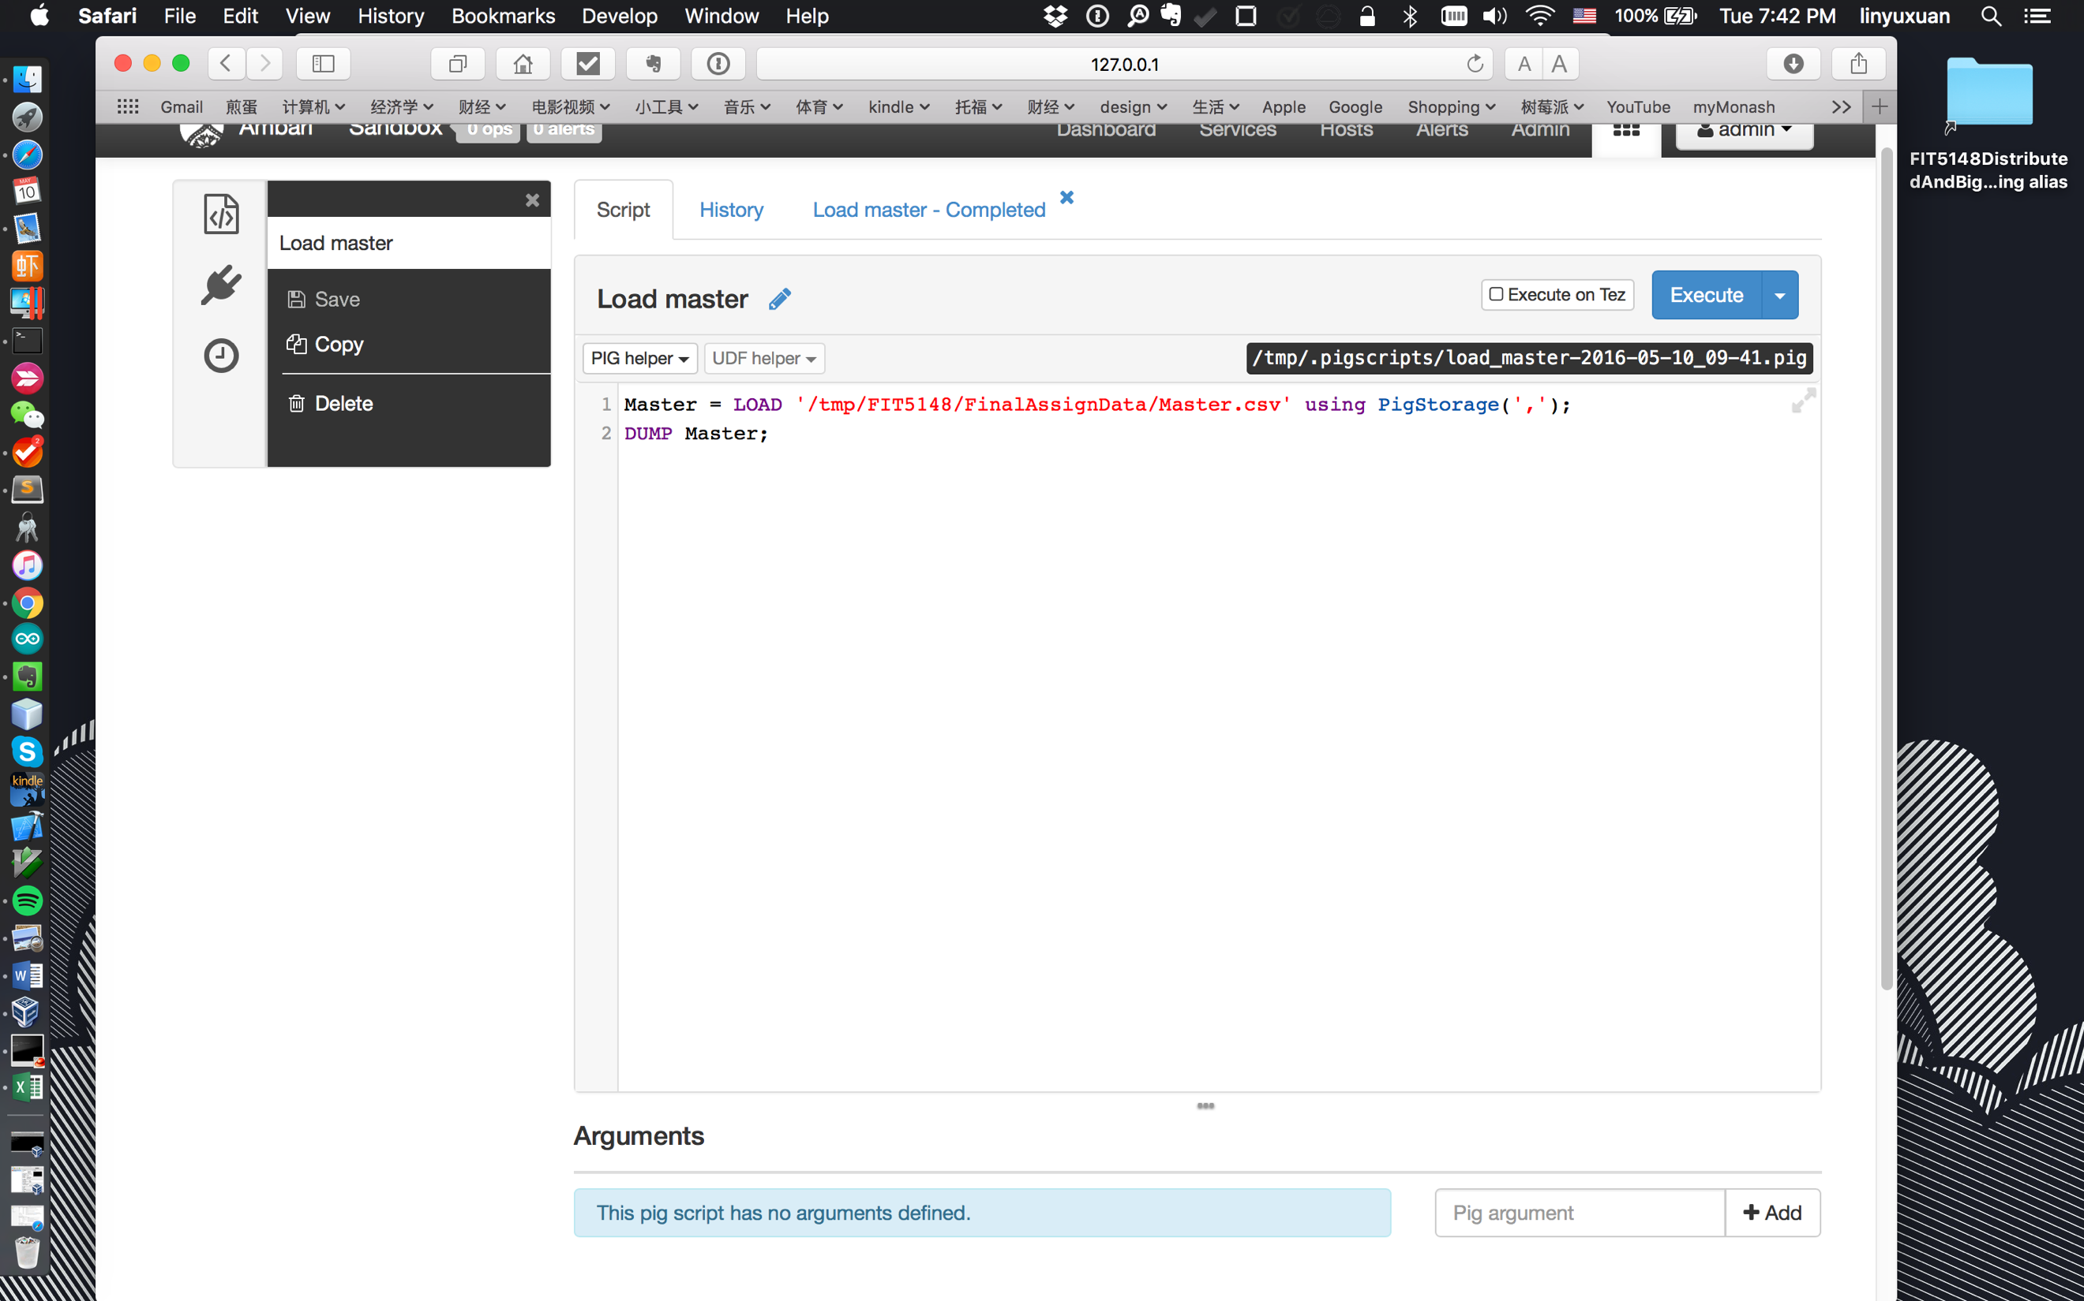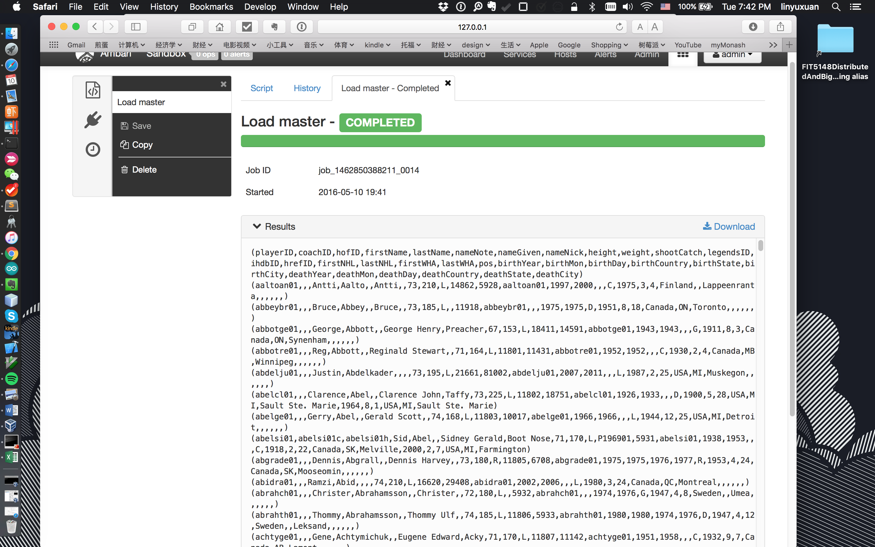

Scoring table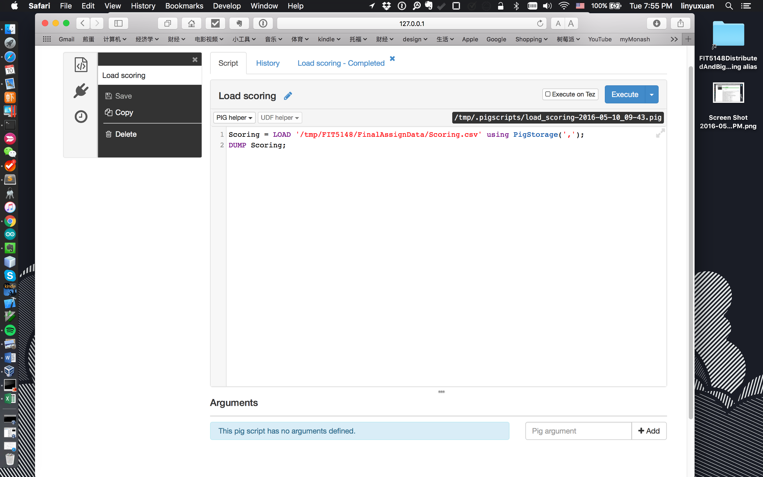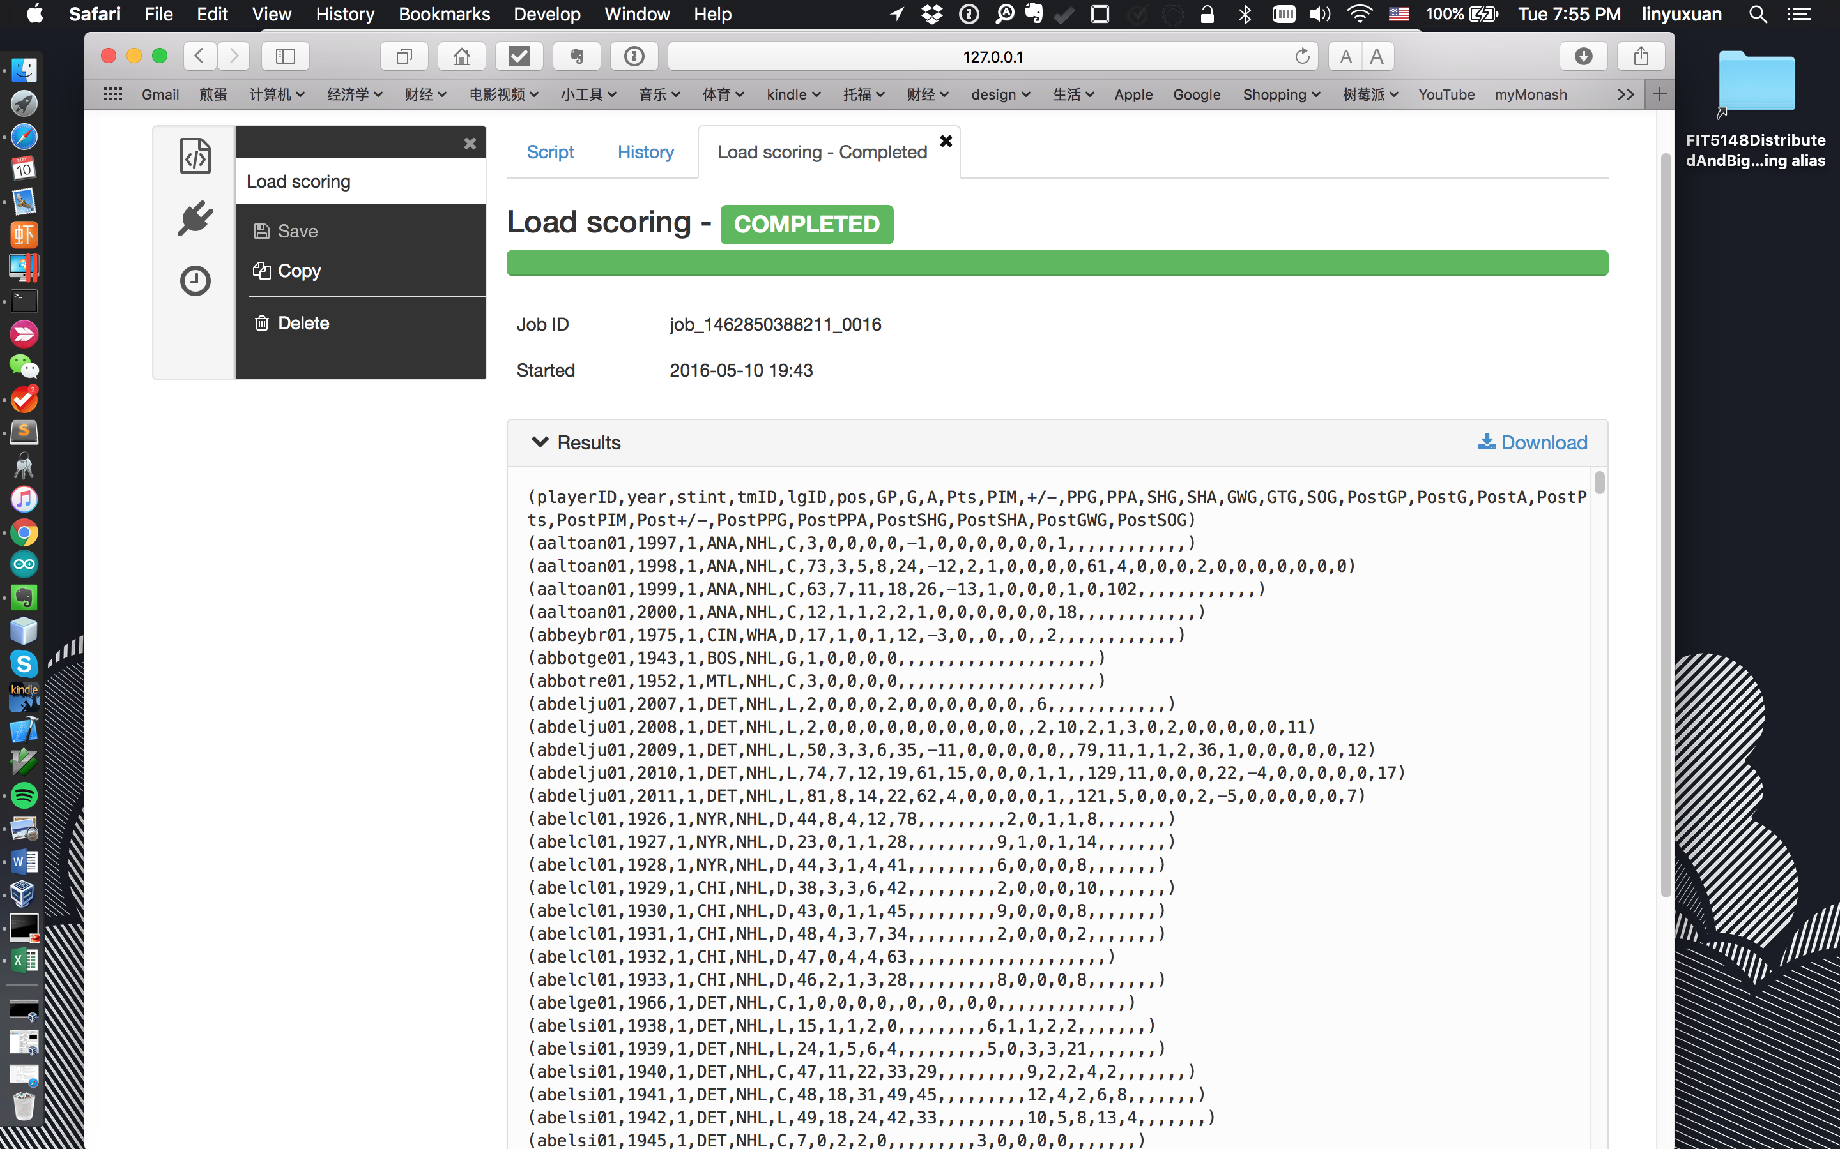

Teams table

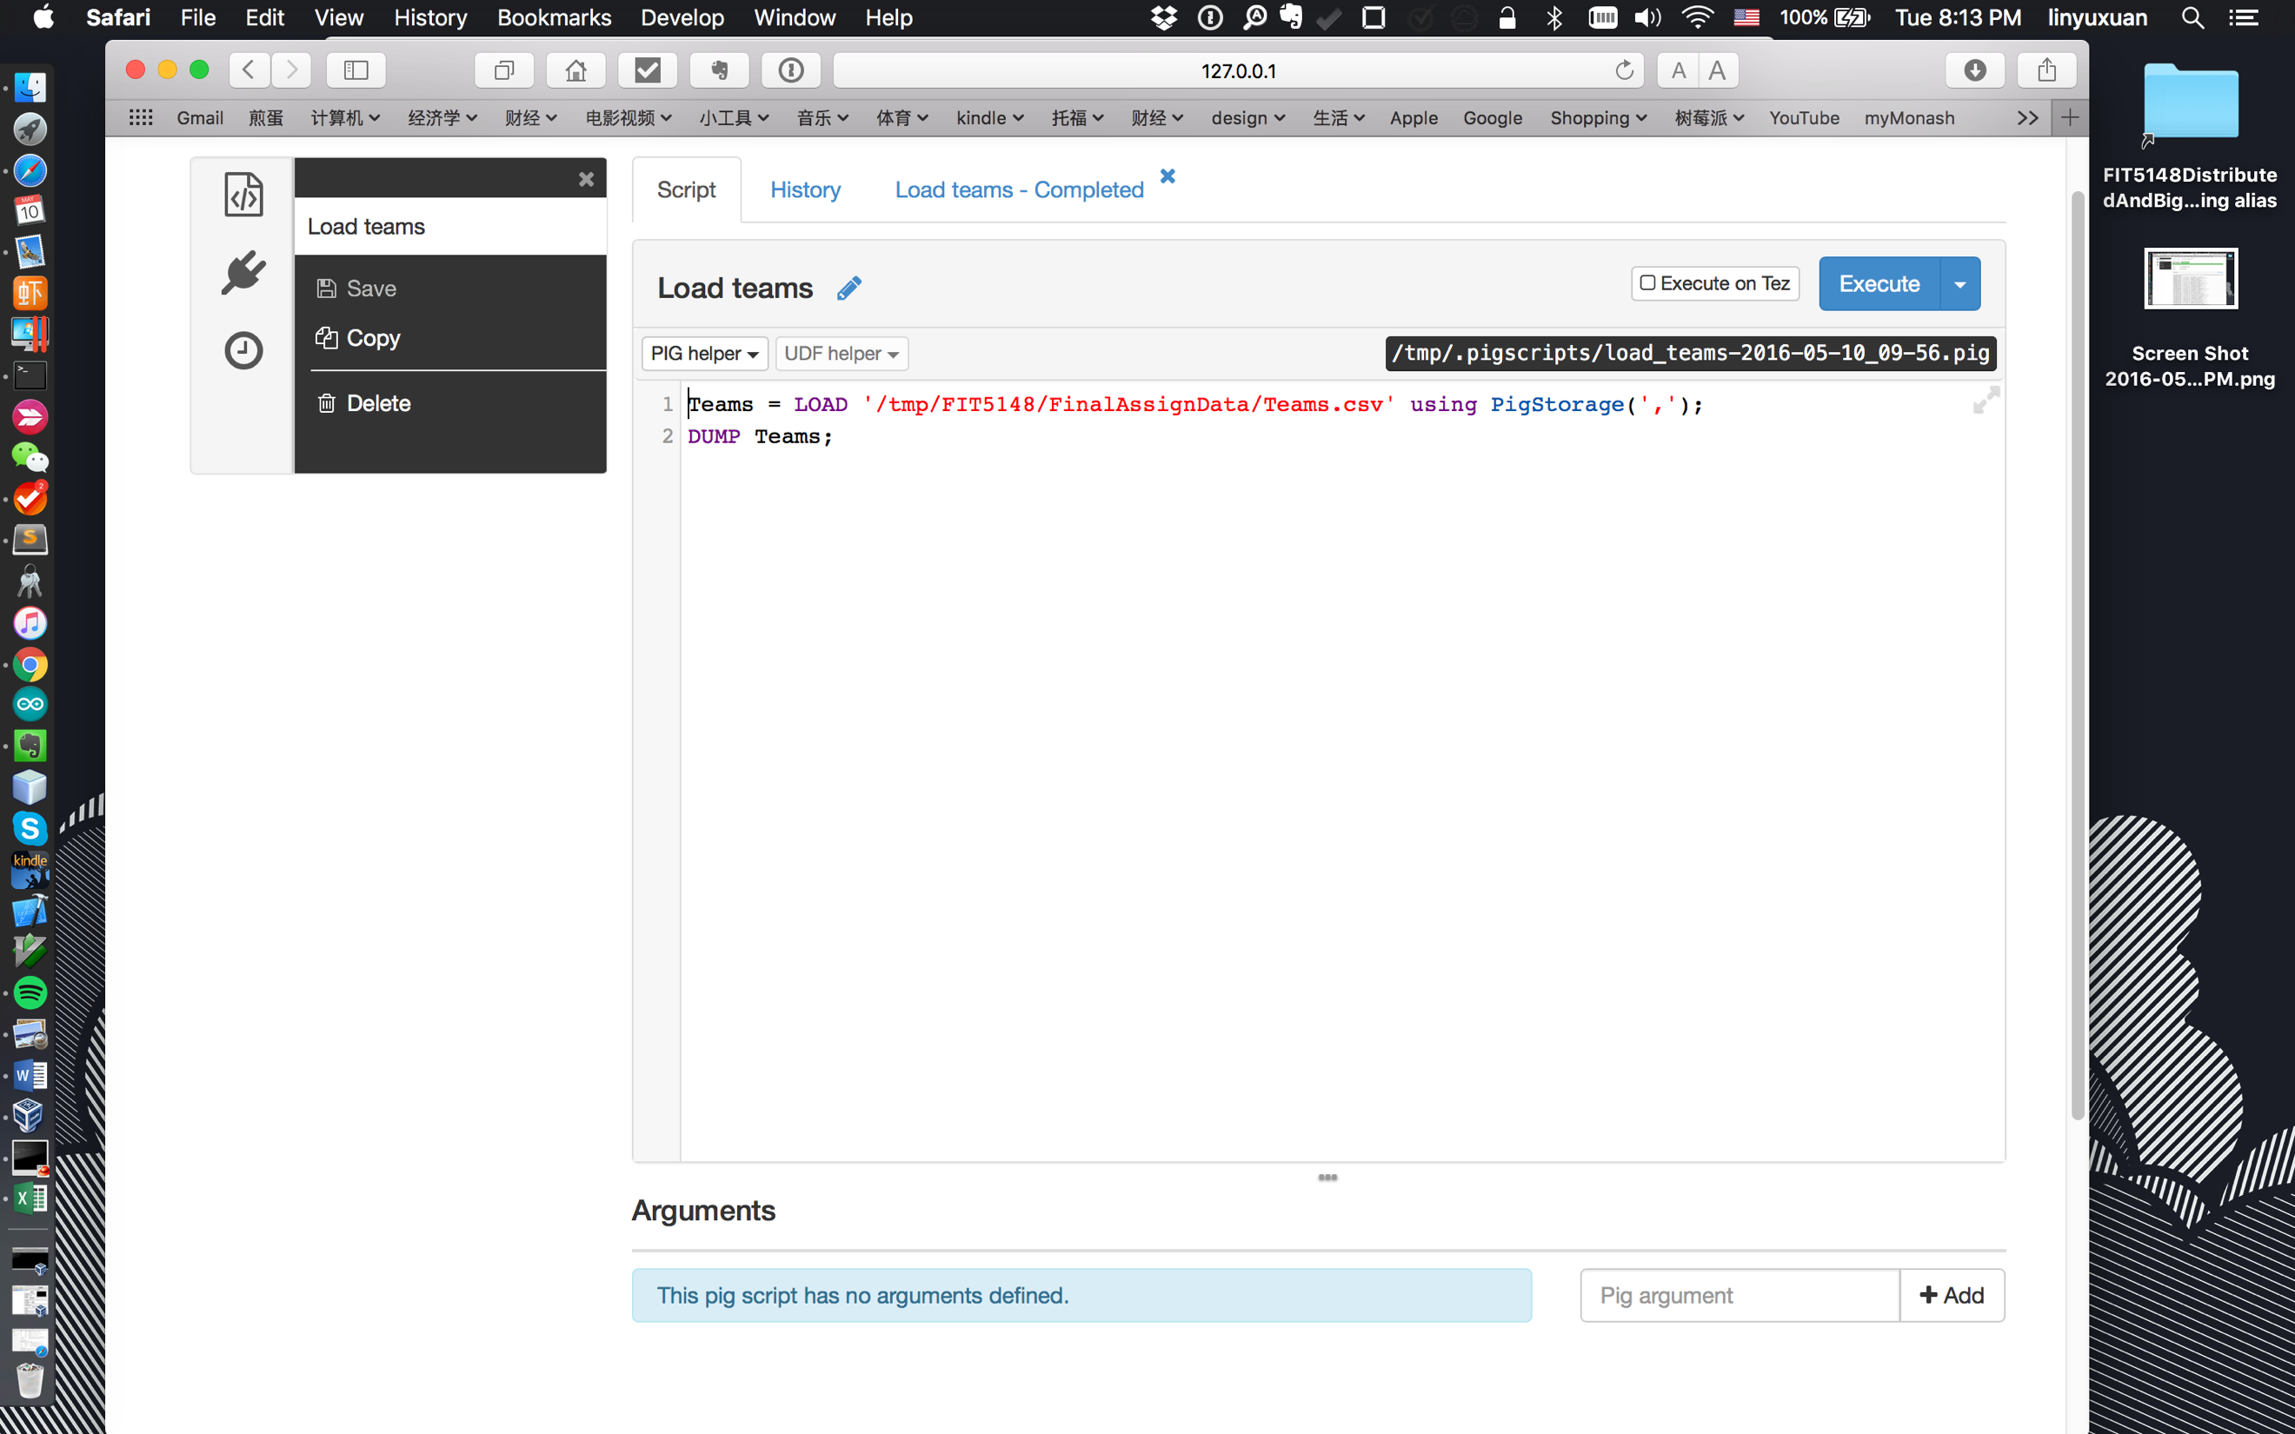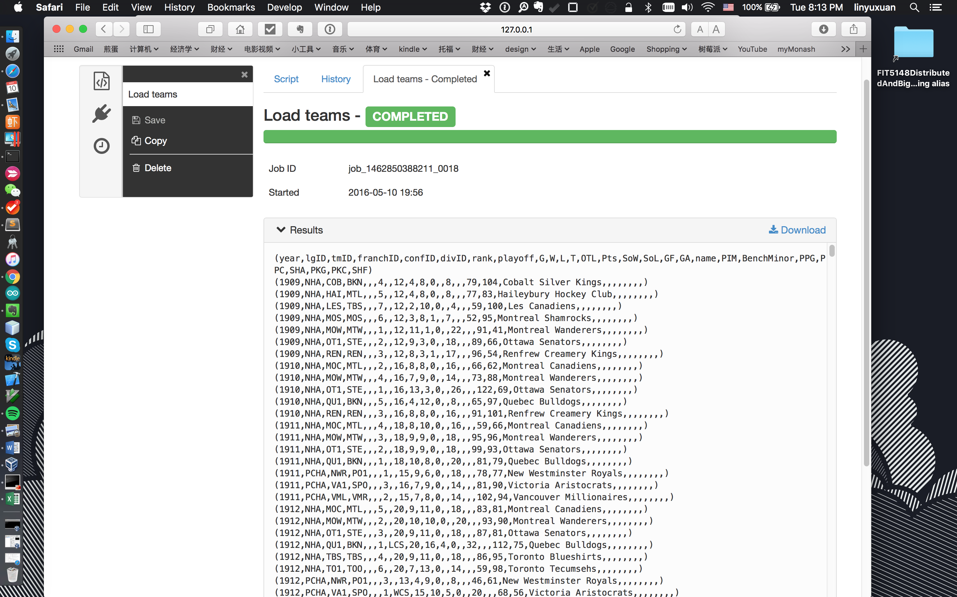

**Task 2 Players (6 marks):**

* a)  Find out the player/s who had the highest GWG (you can repeat a player if the year is different). In the query results show the following details: year, player first and last names, date of birth (day, month and year), country of birth, and team name and league ID, their positions, and GWG.

Hive:

SELECT

s.gwg as MaxGWG, s.year as year, s.pos,

m.firstname, m.lastname, m.birthday, m.birthmon, m.birthyear,m.birthcountry

FROM scoring s

JOIN (SELECT max(gwg) as gwg FROM scoring ) max

ON (s.gwg = max.gwg)

JOIN master m

ON (s.playerid = m.playerid)

JOIN teams t

ON (t.tmid = s.tmid and t.year = s.year);

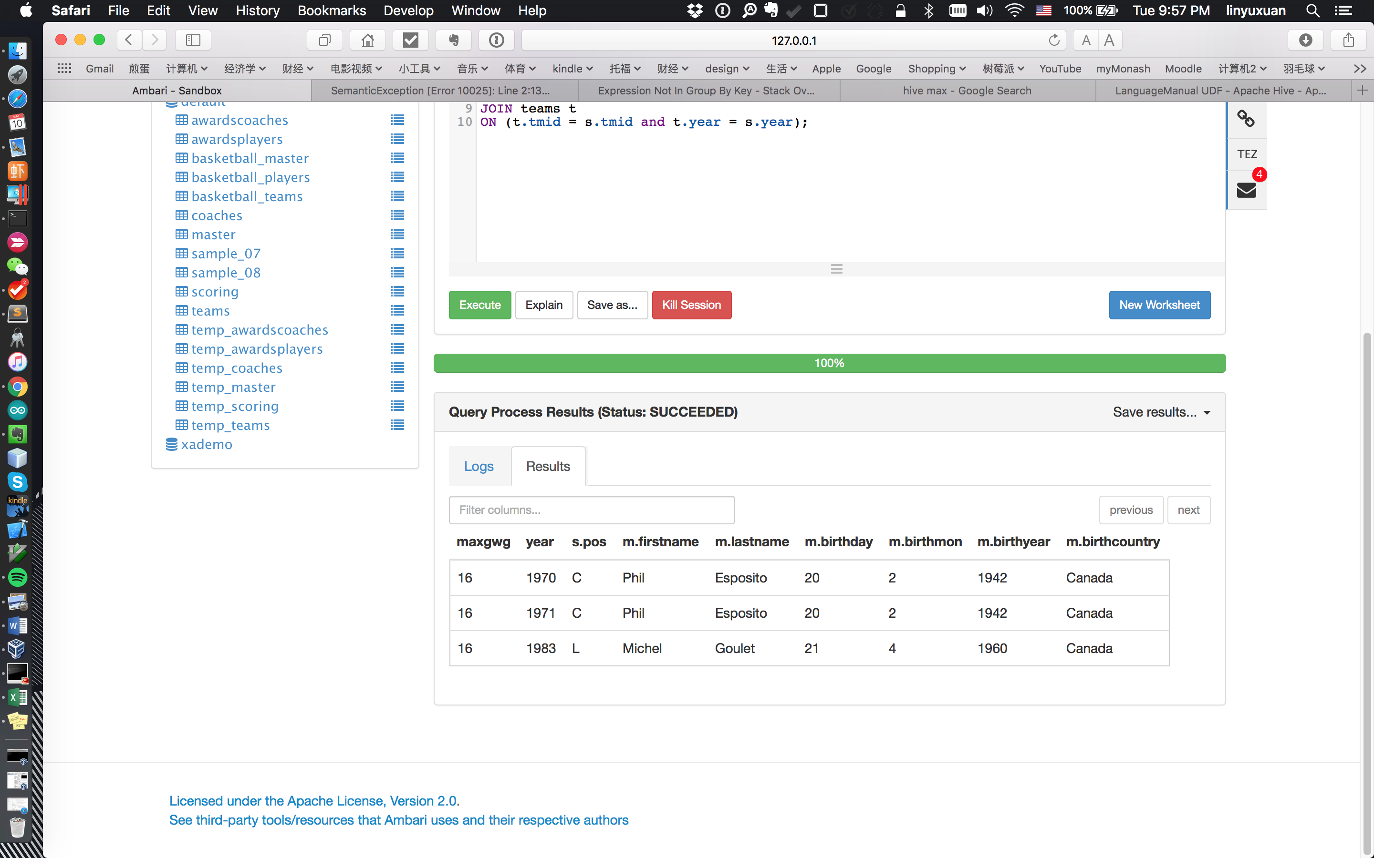

Pig:

* b)  Among those player/s who had the highest GWG, find out the player who had won the highest number of awards. In the query results show the following details: player first and last name, and award count.
* c) Then using the first and last name of the player who had won the highest number of awards find out the points that the player had earned for each year that the player received an award. Display the following details: the award names, the award year, and the points/Pts that the player scored that year.
* −  You will write the queries for the following questions in both **pig and hive**.
* −  Record and compare the Hive and Pig based on the total time taken as well as other factors  such as no of jobs, maps and reducers, etc.
* −  You will provide **your hive queries, pig scripts and the screenshots of the results** (and tables).